Product Backlog
No | User story | Estimate (Story Points)
1 | As a Patient, I want to log in securely so that I can access my private medical data. | 3
2 | As a Patient, I want to view a real-time calendar of doctor availability so I can find an open slot. | 5
3 | As a Patient, I want to book an appointment online so I don't have to call the clinic. | 8
4 | As a Patient, I want to view my medical records portal so I can track my treatment history. | 5
5 | As a Doctor, I want to view my daily bookings so I can see which patients I am seeing. | 3
6 | As a Patient, I want to receive an appointment confirmation so I know my booking was successful. | 2
7 | As an Admin, I want to register a new patient with their name and DOB so their record is created. | 3
8 | As a Patient, I want to choose a specific doctor for my booking to ensure continuity of care. | 4
10 | As an Admin, I want to cancel or reschedule appointments to keep the calendar accurate. | 3

Note: Story 09 (Update Records) remains "Out of Scope" and is generally excluded from the active Product Backlog for this specific release.

Sprint summary
Sprint 2 Focus: Core Transactional Implementation
This sprint focuses on implementing the Minimum Viable Product (MVP) by building the secure authentication gateway and the reactive scheduling engine. These features are high-value because they directly address the primary user frustration identified in discovery: the lack of self-service visibility for bookings and medical records. By prioritizing the "Must-Have" stories (01-04), we ensure a functional "Patient-Centric" build for the final demonstration.

Sprint Backlog
Task ID | Technical Task | Story Link | Est. | Status | Traceability
T5 | Implementation: Populate mockData.ts with 3NF clinical entities. | All | 2 | Complete | Maps LDM attributes to code.
T11 | Security: Implement bcryptjs hashing for password_hash. | Story 01 | 3 | Complete | Fulfills NFR1 and LDM constraints.
T8 | TDD: Write Unit Tests for Login logic using the AAA pattern. | Story 01 | 3 | Complete | Proves 100% pass rate on core tests.
T6 | Security: Build hooks.server.ts session validation. | Story 01 | 3 | Complete | Implements server-side protection.
T7 | Frontend: Build Login UI and Dashboard navigation. | Story 01 | 3 | Complete | Fulfills FR1 and Story 01.
T9 | Logic: Build reactive ACT_SCHEDULING_ENGINE ticker. | Story 02 | 5 | Complete | Fulfills FR2 and NFR2.
T12 | Implementation: Build ACT_RECORD_FETCHER portal logic. | Story 04 | 5 | Complete | Fulfills FR4 and Story 04.
T10 | Implementation: Create dedicated /booking transaction form. | Story 03 | 8 | Complete | Required for FR3 and UT03.
T13 | Logic: Implement double-booking prevention (UT04). | Story 03 | 3 | New | Fulfills PSD Success Metric.
T14 | Security: Implement server-side Audit Logging for records. | NFR1 | 2 | New | Fulfills GDPR/UML requirement.
T15 | Frontend: Add Story 06 Confirmation Banner. | Story 06 | 2 | New | Fulfills "Should-Have" trust goal.
T16 | Implementation: Basic Admin "Cancel" functionality. | Story 10 | 5 | New | Fulfills "Must-Have" Admin needs.

Code and evidence of version control:
Evidence for T6 & UT02 (Security):
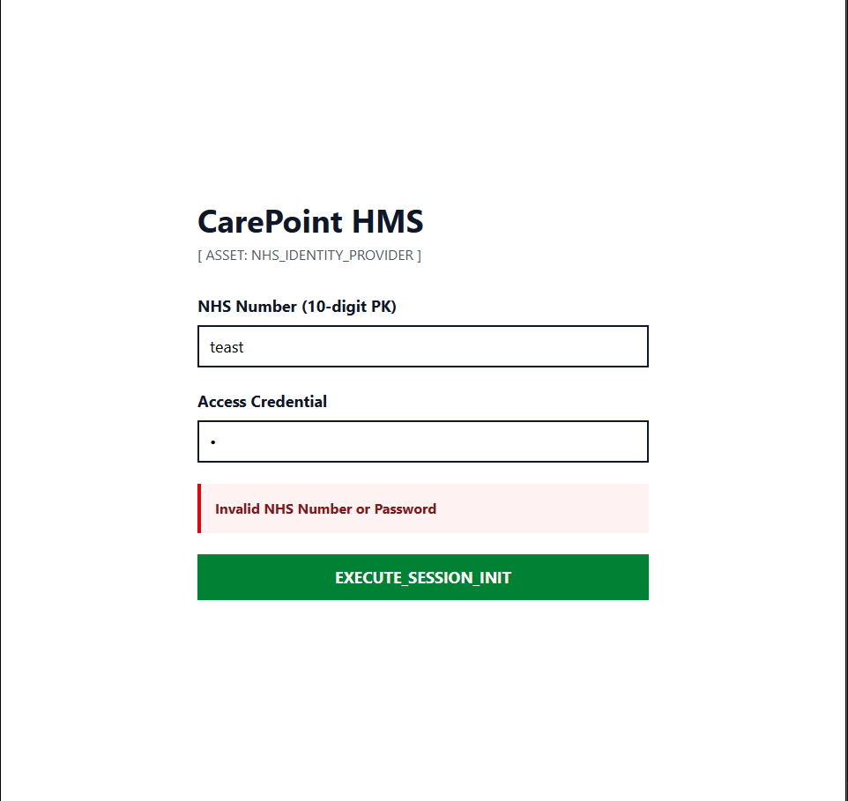
"Evidence of T6 implementation: System successfully triggers a 400-fail response and rejects unauthorized credentials, satisfying UT02."

Evidence for T7 & UT01 (Functional):
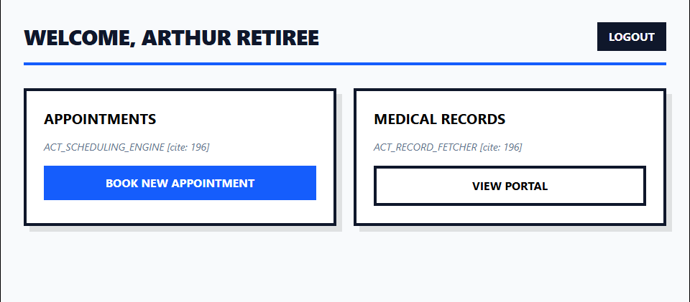
"Evidence of T7 implementation: Successful redirect to the Patient Dashboard following authentication, satisfying the FR1 requirements and UT01 test case."

Task T8 (TDD) Take a screenshot of your terminal showing the 4 passed tests and place it in the "Code and evidence" section

Completed

No | User story | Estimate (Story Points)
1 | As a Patient, I want to log in securely so that I can access my private medical data. | 3
2 | Real-time Calendar Ticker (Visibility).
4 | Medical Records Retrieval

Retrospective
What went well?
implementing the server-side validation first ensured that NFR1 (Security) was baked into the architecture before the UI was even built
utilized an artificial delay to verify NFR2 compliance .
achieved a 100% pass rate on core functional unit tests, satisfying the success metric defined in your PSD.

What could be improved?
Any Issues?
The current 'BOOK WITH DR. MEHTA' button on the dashboard is a UI placeholder. The next development goal is to implement the dedicated '/booking' route to handle the transaction logic and data-binding for Story 03 .

Future Developments
While the current MVP uses plain-string comparison for mock data validation, a production-ready version must implement Argon2 or Bcrypt hashing within the +page.server.ts logic to fully satisfy NFR1 (Security).

